**Access Oslo Project**

[**www.fantasylab.no/accessoslo**](http://www.fantasylab.no/accessoslo)

**Create 6 templates which have these differences at the top of the page:**

1. Slideshow on the left side & text box on the right side
2. Text box on the left side and image box on the right side
3. A 100% width image box with title on the image
4. 100% width video box at the top like on the front page
5. Image to the left and text box to the right
6. 100% width image at the top like on the front page

**Airport Transport –** Slideshow on the left side &text box on the right side

**Meet & Greet –** Text box on the left side and Image box on the right side

**Departure & Arrival –** A 100% width image box (title should be on the image)

**Facilities –**Slideshow on the left side &text box on the right side

**Direct Boarding & Board to Board –**Text box to the left and slideshow to the right

**Limousine Service –** 100% width image box with title on the image

**Business Aircraft & Passenger Aircraft –** 100% width video box at the top

**Cargo Aircraft –** Image to the left and text box to the right

**Business Helicopter & Cargo Helicopter –** 100% width image at the top

**VIP Courier –** Image to the left and text box to the right

**Safety –** 100% width image at the top

**You and your car –** Image box to the left text box to the right

**Limousine Transport –** 100% width image at the top

**Your work here will be to create specific input fields inside the popup which will appear after you have clicked a button. The popup will be like the "REQUEST A CALLBACK" button on the top section. You can use the same popup code but only different fields.**

Meet & Greet page / <http://fantasylab.no/accessoslo/meet-and-greet/>

This is information which will be in the popup after you have clicked "Book Meet & Greet" button

Title: Departure of Arrival

Field 1: Name

Field 2: Email

Field 3: Telephone

Field 4: Flight No

Field 5: Date of flight

Field 6: Time of departure / arrival

Field 7: Number of bags

Field 8: Fast track Yes/No

Field 9: VIP-lounge Yes/No (only on departure)

Add another person

Book Meet & Greet

"We will send you a confirmation by email."

Direct Boarding /<http://fantasylab.no/accessoslo/direct-boarding/> and

Board to Board / <http://fantasylab.no/accessoslo/board-to-board/>

This is information which will be in the popup after you have clicked "Book your direct boarding" button

Title: Departure or arrival

Field 1: Name

Field 2: Email

Field 3: Telephone

Field 4: VIP - Airport transport yes/no

Field 5: Flight No

Field 6: Date of departure / arrival

Field 7: No of bags

"Add another passenger?"

Business Aircraft /<http://fantasylab.no/accessoslo/business-aircraft/> and

Passenger Aircraft / <http://fantasylab.no/accessoslo/passenger-aircraft/> and

Cargo Aircraft / <http://fantasylab.no/accessoslo/cargo-aircraft-charter/>

These pages will **not** have a popup, these fields will be on the page at the bottom white box where you can see rest of the content/text

H2 Title: Aircraft quote:

Field 1: Date

Field 2: From / To (Is it possible to get keyword for specific airports, like when you book a flight you can see all the airports you can select from?)

Field 3: Select amount of passengers

Field 4: Name

Field 5: Email

Field 6: Phone

Limousine Transport / <http://fantasylab.no/accessoslo/limousine-transport/>

This page will **not** have a popup, these fields will be on the page at the bottom white box where you can see rest of the content/text. You can keep the same design of the fields like in the popup for "REQUEST A CALLBACK" on top of page

Field 1: Navn

Field 2: Epost

Field 3: Telefon

Field 4: Dato

Field 5: From / To (Is it possible to get keyword for specific airports, like when you book a flight you can see all the airports you can select from?)

Field 6: Amount of passengers

"Book your limousine" button

Front page / <http://fantasylab.no/accessoslo>

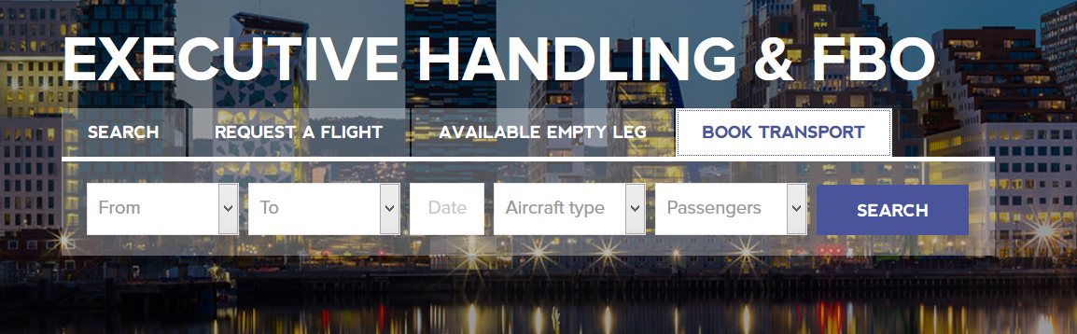

These fields must be:

Field 1: Date

Field 2: Time of pick up

Field 3: Pick up address

Field 4: Number of people

Field 5: Name

Field 6: Email

Field 7: Telephone

Field 8: Additional information

**Create a "switch" function for the FBO/CREW button in the header**

If someone clicks "FBO/CREW" button in the header, the navigation menu links and the boxes on front page will change

**Navigation menu will be:**

**Facilities**

* Lounges
* Terminal
* Ramp

**Services**

* Aircraft services
* FBO services

**Access Loyalty**

* Become a member
* For members

**Testimonials**

**Partners**

**About us**

**Boxes for the front page will be:**

* FBO services
* Brand new facilities
* Attention to details
* Access Loyalty program
* Latest news from our blog
* Safety is a culture
* Partner of the month

When you have clicked "FBO/CREW" the new text for the button will be "PASSENGER". If you click "PASSENGER" again you will go back to the original website

**Available Empty Leg on the front page menu**

Access Oslo must be able to add available empty legs from back end. And on front page users/customers will be able to search for those available empty legs which Access Oslo has added from the back-end. You will create HTML/CSS/PHP Code to make this work flawlessly. Please view attached design files for more information

1. **User searches for Available empty leg**

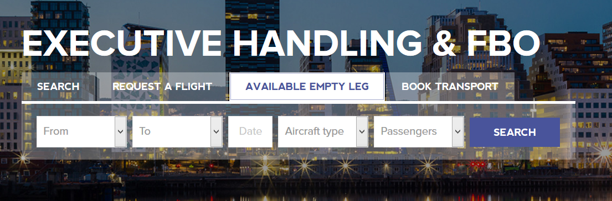

1. **User sees all available empty legs according to his/her search**

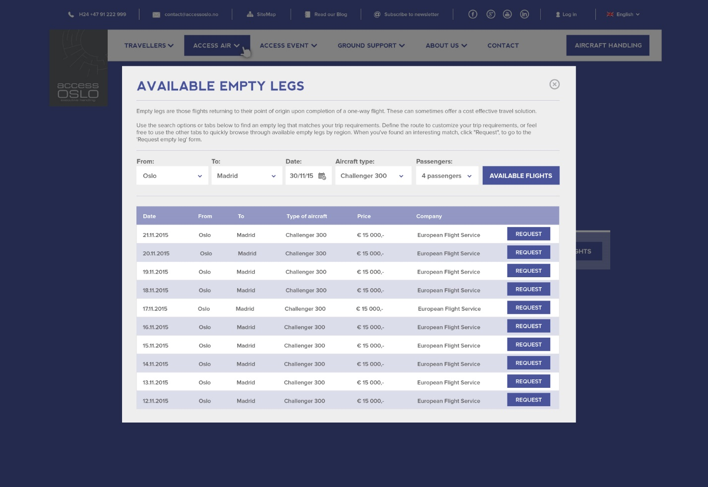

1. **User can request empty leg and submit this request to Access Oslo**

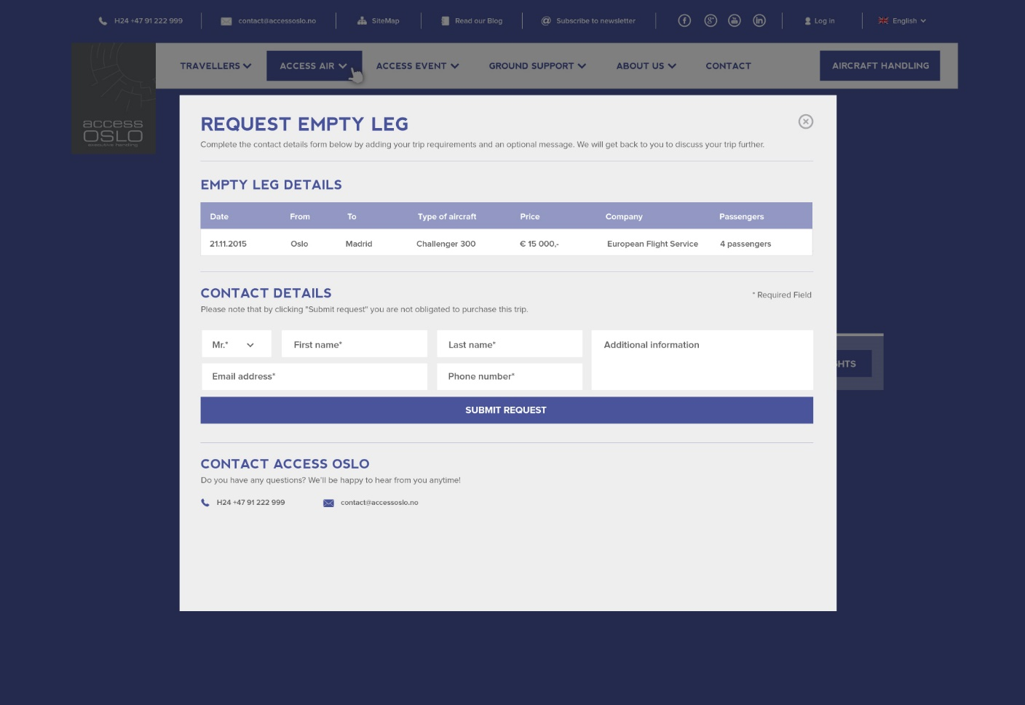

**Access Loyalty Program**

* A Login page and "Become a member" page
* Possible for Access Oslo to register points from back-end to their customers
* A page which tells about the "The Bonus Scheme"
* Customer can select 5 products which they can cash in, in one action
* The products have a certain point quantity
* All customers must be able to see a balance of their points
* Customers should be able to register for specific newsletter and offers
* A page where user can add/change their name, email, phone, address, password etc.
* Installation of SSL for [www.accessoslo.no](http://www.accessoslo.no)

**Partners & Testimonials Pages**

* These pages will have boxes with correct testimonials title. If the box is clicked you will get redirected to a page with detailed information about how Access Oslo and client is working together and what Access Oslo has delivered. It will be simple design. I will send you this.

**Which functionality the back-end must have**

* Client must be able to create New testimonials and partners pages from back-end
* Client must be able to edit all content for pages from back-end
* Client and Partners must be able to add "Available Empty Legs" from back-end which users can search for
* Client must be able to give out Bonus Points to users
* Client must be able to create blog posts from back-end
* Client must have an overview of all his newsletter subscribers in back-end

**Overall you will have to give us support and help us with launch of** [**www.accessoslo.no**](http://www.accessoslo.no) **when the developing is done. It might be some small CSS changes here and there, but these tasks above are the main tasks which need to be added.**

**I will send you design for Access Loyalty Program and the 6 different top templates as soon as we are done with the integration of Access Oslo in CodeIgniter or Laravel**